Summer Olympics Medal Analysis

Name: Riya Mahesh Kadam
Student ID: AF05210105
Batch Code: ANP-D4853
Project Name: Summer Olympics Medal Analysis Dashboard using Power BI
Project Guide: Ms. Rajashri Thete

Objective
The objective of the Olympics Data Analysis project is to extract meaningful insights, identify performance trends, and visualize Olympic statistics using Microsoft Excel and Power BI. The project focuses on understanding athlete participation, medal distribution, country-wise performance, sports-wise achievements, and gender analysis from the Summer Olympics dataset.
Exploratory Analysis
- Understanding country-wise medal performances.
- Comparing Gold, Silver, and Bronze medal distributions.
- Analysing sport-wise athlete participation.
- Studying gender participation across different sports.
Data Visualization
- Representing Olympic statistics using KPI Cards, Bar Charts, Column Charts, Pie Charts, Line Charts, and Tables.
- Creating interactive dashboards for easy analysis.
- Comparing country and sport performances through visual reports.
Performance Analysis
- Identifying countries with the highest medal counts.
- Comparing medal distribution across different sports.
- Analysing athlete participation by gender.
- Studying overall Olympic performance trends.

Dashboard Development
- Building interactive dashboards using Microsoft Excel and Power BI.
- Using Power Query for data cleaning and transformation.
- Creating KPIs, Pivot Tables, Pivot Charts, Slicers, and DAX measures for better analysis.
- Designing user-friendly dashboards for effective data interpretation.

Problem Statement
The Summer Olympics generate a large volume of data related to athletes, countries, sports, events, and medals. Analysing this data manually is complex and time-consuming. This project uses Microsoft Excel and Power BI to clean, analyse, and visualize Olympic data through interactive dashboards. The project focuses on analysing medal distribution, country and sport performance, athlete participation, and presenting meaningful insights using KPI cards, charts, slicers, and other visualizations for effective decision-making.

3. Data Description
3.1 Source
The dataset used in this project was obtained from Kaggle, one of the most popular online platforms for open datasets used in data analysis and machine learning projects. The dataset contains historical records of Summer Olympic Games, including details of athletes, countries, sports, events, genders, medals, Olympic years, and host cities.
The dataset was selected because it provides comprehensive information required for analysing Olympic performance from different perspectives. Before analysis, the dataset was examined for missing values, duplicate records, inconsistent entries, and formatting issues. Data cleaning and transformation were carried out using Microsoft Excel and Power Query to ensure accuracy and consistency.
The cleaned dataset was then imported into Microsoft Power BI for creating interactive dashboards and visual reports. These dashboards help users understand Olympic statistics through charts, KPIs, slicers, and tables.

3.2 Data Model
The data model defines the structure of the Olympics dataset and organizes the data for efficient analysis and visualization. It establishes relationships between key attributes such as athletes, countries, sports, events, medals, and Olympic years.
The dataset follows a tabular structure, where each row represents an athlete's participation in an Olympic event. This organized structure enables efficient filtering, grouping, calculations, and analysis using Microsoft Excel Pivot Tables and Power BI, helping generate meaningful insights through interactive dashboards.

3.3 Data Model Overview
The Summer Olympics dataset contains multiple attributes that describe athlete participation and Olympic achievements. Each attribute plays an important role in analysing performance across countries, sports, and Olympic editions.

Entities and Attributes
Attribute Name | Description
Athlete | Name of the athlete who participated in the Olympic event.
Gender | Gender of the athlete (Men or Women).
Age | Age of the athlete during participation.
Country | Country represented by the athlete.
Sport | Name of the sport in which the athlete competed.
Event | Specific event under a particular sport.
Medal | Type of medal won (Gold, Silver, Bronze).
Year | Year in which the Olympic Games were held.
Season | Olympic season (Summer).
City | Host city where the Olympic Games were conducted.

Additional Calculated Fields Used
To improve analysis and dashboard reporting, several calculated measures and summary fields were created using Excel formulas, Pivot Tables, and DAX measures in Power BI. These include:
- Total Athletes
- Total Countries
- Total Sports
- Total Events
- Total Medals
- Gold Medal Count
- Silver Medal Count
- Bronze Medal Count
- Country-wise Medal Count
- Sport-wise Medal Count
- Gender-wise Athlete Count
These calculated values are displayed as KPI cards and used throughout the dashboards.
3.4 Data Relationships
The Olympics dataset contains logical relationships between athletes, countries, sports, events, medals, and Olympic years, making it suitable for analysis and dashboard creation.
- Each athlete represents a specific country and participates in one or more Olympic events.
- Every event belongs to a particular sport, while each sport consists of multiple events.
- Medal information (Gold, Silver, and Bronze) is linked to the respective athlete and event.
- Countries are represented by multiple athletes participating in different sports and events.
- Gender information is used to analyse participation among male and female athletes.
- Olympic Year and Host City help compare performances across different Olympic editions.
- The cleaned dataset is connected to Pivot Tables, Pivot Charts, and KPI Cards in Microsoft Excel and imported into Power BI for creating interactive dashboards and reports.

3.5 Data Processing
Before creating the dashboards, the dataset underwent several preprocessing steps to ensure accurate analysis and reliable visualizations.
- Imported the Summer Olympics dataset from Kaggle into Microsoft Excel.
- Checked the dataset for missing values, duplicate records, and inconsistent entries.
- Removed duplicate and unnecessary records from the dataset.
- Corrected data types, formatting errors, and standardized country and sport names.
- Used Power Query to clean and transform the data for analysis.
- Created Pivot Tables and Pivot Charts to summarize Olympic statistics in Excel.
- Designed KPI Cards to display important metrics such as Total Athletes, Countries, Sports, Events, and Medals.
- Imported the cleaned dataset into Microsoft Power BI.
- Created DAX measures and developed interactive dashboards using charts, slicers, and filters.
Project Result
1. Data Collection and Preparation
The Summer Olympics dataset was collected from Kaggle in CSV format and imported into Microsoft Excel. The dataset was cleaned by removing duplicate records, handling missing values, correcting data types, and standardizing country and sport names. Power Query was used to transform the data before importing it into Microsoft Power BI.
Result:
- Successfully prepared a clean and structured dataset.
- Improved data quality for accurate analysis.
- Created a reliable foundation for dashboard development.
2. KPI Dashboard
The dashboard includes KPI Cards displaying:
- Total Athletes
- Total Countries
- Total Sports
- Total Events
- Total Medals
- Gold, Silver, and Bronze Medal Counts
These KPIs provide an instant summary of Olympic statistics and update dynamically when filters are applied.
Result:
The KPI section provides a quick overview of the overall Olympic performance and helps users understand key statistics at a glance.
3. Country-wise and Sport-wise Analysis
Clustered Column Charts and Bar Charts were created to analyse country-wise medal counts and sport-wise participation. These visualizations help compare the performance of different countries and identify sports with the highest participation and medal counts.
Result:
- Identifies top-performing countries.
- Highlights sports with the highest participation.
- Makes comparison easier through interactive visualizations.

4. Medal Distribution and Gender Analysis
Pie Charts and Donut Charts were used to represent the distribution of Gold, Silver, and Bronze medals, while Bar Charts were used to compare male and female athlete participation.
Result:
- Shows the percentage distribution of different medal types.
- Compares male and female athlete participation.
- Helps understand Olympic participation patterns.

5. Interactive Dashboard
The dashboard includes KPI Cards, Pivot Tables, Charts, and Slicers that allow users to filter data by Country, Sport, Gender, Medal Type, and Olympic Year. All visuals update dynamically based on the selected filters.
Result:
- Provides an interactive and user-friendly dashboard.
- Enables quick filtering and comparison of Olympic statistics.
- Improves decision-making through meaningful visual reports.
Dashboard:
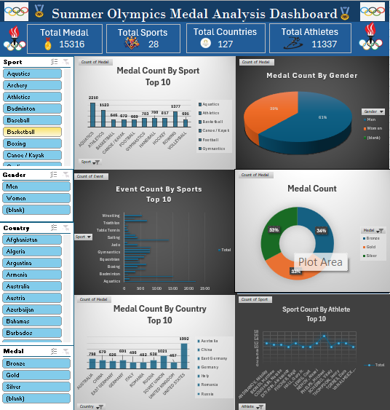
Excel Dashboard:

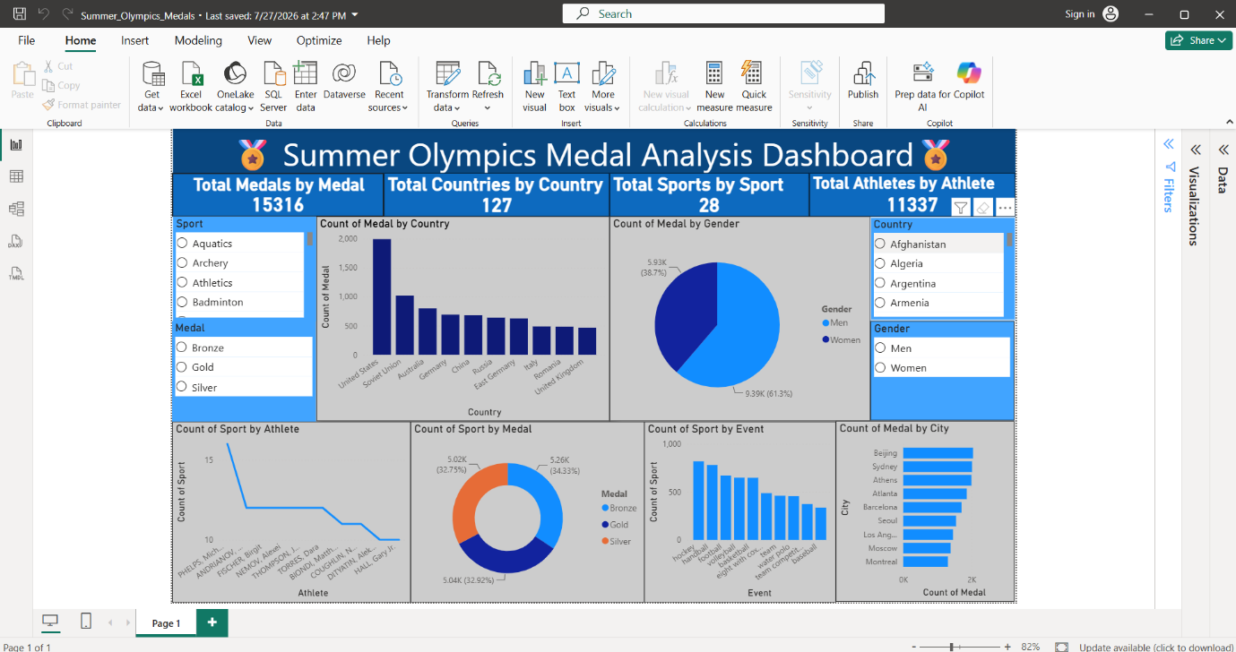
Power Bi Dashboard

Conclusion
The Olympics Data Analysis using Microsoft Excel and Power BI project successfully demonstrates how Business Intelligence tools can convert raw Olympic data into meaningful insights through interactive dashboards. The project involved collecting and cleaning the dataset, performing data analysis, and developing dashboards using KPI Cards, Pivot Tables, Charts, Slicers, and DAX measures.
The dashboards provide valuable insights into athlete participation, medal distribution, country performance, and sport-wise achievements. By combining Microsoft Excel and Power BI, the project presents Olympic statistics in a simple, interactive, and visually appealing format. It also demonstrates practical knowledge of data cleaning, transformation, visualization, and dashboard development, making it an effective Business Intelligence solution for Olympic data analysis.

